|  |  |  |
| --- | --- | --- |
|  |  |  |

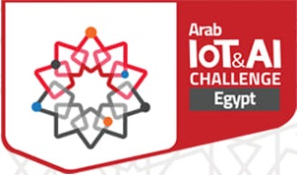**Egypt IOT and AI Challenge 2020**

**Graduation Projects Track**

**Detailed Project Progress Report GP (20-57)**

**Arabic Sign Language (ARSL) Interpreter**

**------------------------------------------------------------------------------------------------------------------------------------**

**Submitted By**

|  |  |
| --- | --- |
| **Mahmoud Aboud Nada**  **MennatuAllah Ahmed El-Zahaby**  **Hesham Abdullah Al-Kholey** | **Asmaa Hasan Dardarah**  **Muhammad Ali Shokair**  **Omar Ibraheem Shaheen** |

**Supervisor**

**Professor/ Wessam Fekrey**

**DEPARTMENT OF ELECTRICAL ENGINEERING**

**KAFRELSHEIKH UNIVERSITY**

2020

# 1. Project Presentation and Background

## 1.1. Problem Statement and Motivation

According to the world health organization (WHO), over 5% of the world’s population suffer from deafness or hearing impairment. In Egypt alone there are around 7.5 million people.

Inability to speak or hear is considered to be a true disability. People with this disability use different modes to communicate with others, there are number of methods available for their communication one such common method of communication is sign language. Sign language allows people to communicate with human body language; each word has a set of human actions representing a particular expression. Deaf and mute people can often feel isolated or lonely. This is because they can have difficulty interacting with people on a day-to-day basis, so they feel disconnected from friends, family, their community and the world around them. They want to express themselves, be independent, live life to the fullest, and do all the things like people without disabilities. We aim to help them leave loneliness behind Just as importantly, give them the confidence to reconnect with their family, friends and community, and embrace the life they want to lead. That’s why our motive is to convert the Arabic sign language (ARSL) to spoken voice through human gesture understanding and motion capture models, so they can express what they want to say and everyone would understand.

## 1.2. Goals, Objectives, and Outcomes

## Our main goal is to ease the lives of people suffering from deafness and muteness. We aim at creating a device that can be worn by the deaf and mute people that can capture their Arabic sign language and interpret it to spoken language through microphone so other people who don’t know sign language can understand what they want to say

## The main purpose of our project and product is to ease the daily life communications for the deaf and mute community members. We are offering a way where they will be able to perform all communication activities without help from other people, they will no longer be alone in the society and they will have better work opportunities and experiences.

Our project has many strengths such as:

* it offers Arabic Sign Language interpretation. ARSL has no interpretation systems that are fully functional till now.
* It’s an easy to use device that doesn’t require the user to wear any gadgets on their face, or their hands, they only need to carry around our small device.
* It offers observation of surroundings and alarm notification in case of any dangers.
* It can be turned into a mobile application as an alternative to carrying the device.

## 2. Methodology, Implementation and Results:

## To build a system that can translate full Arabic sign language sentences and turn it from signs to spoken words and turn this idea to a product that can be used by everyone in the deaf and mute community, we started building multiple models to construct our target full model.

**Model #1**

First, we had to gather our own customed dataset that consists of a set of words that we believe are most common in daily life according to sign language instructors. we started with 28 words from 4 different signers each word is repeated 10 times so this makes our initial dataset with 1120 videos.

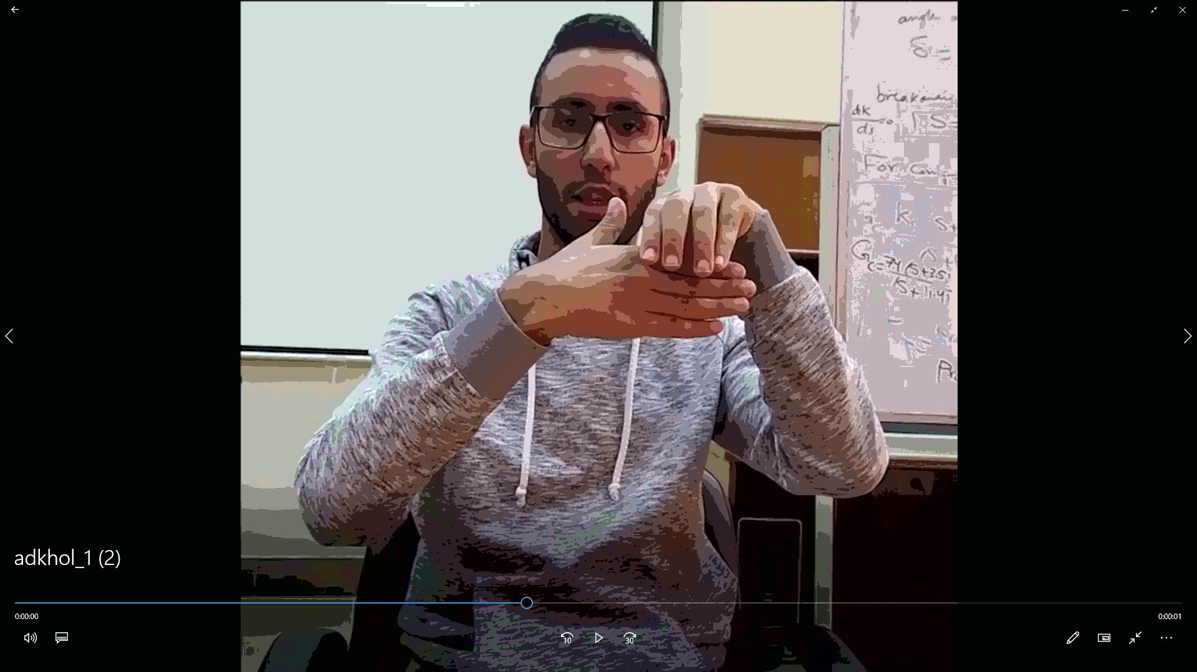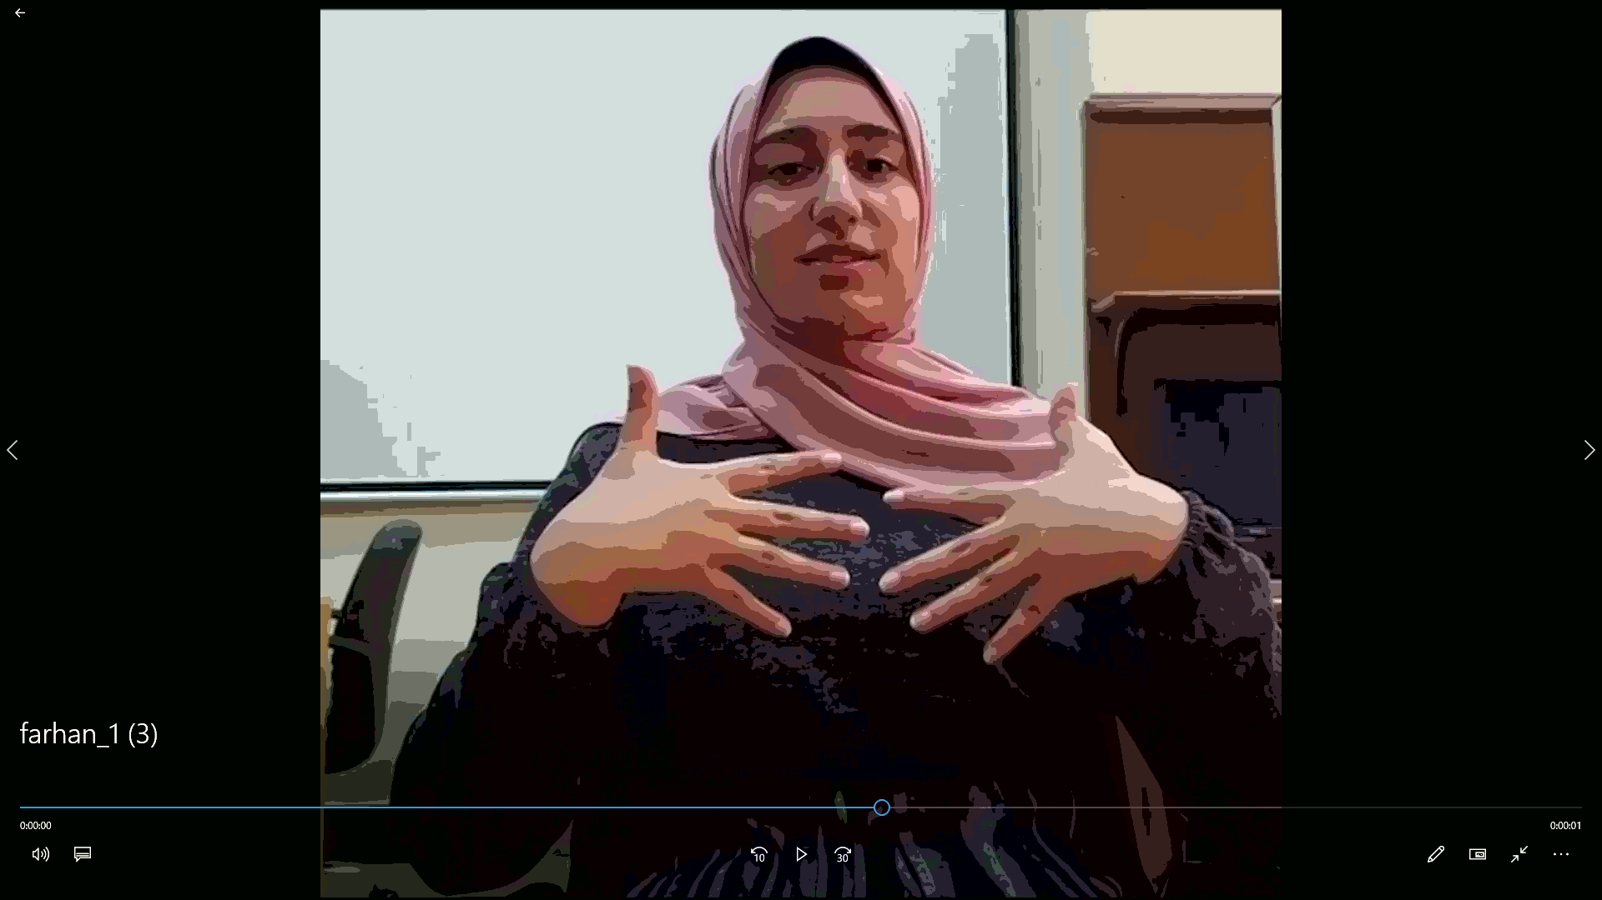

Figure 2.1: Snapshots from the ARSL video dataset

As we were collecting the dataset from local sign language specialists, we started to prepare the code that deals with any video dataset, we used an experimental dataset called UCF101 that is used in action recognition it has 101 classes within each class videos belongs to this class.

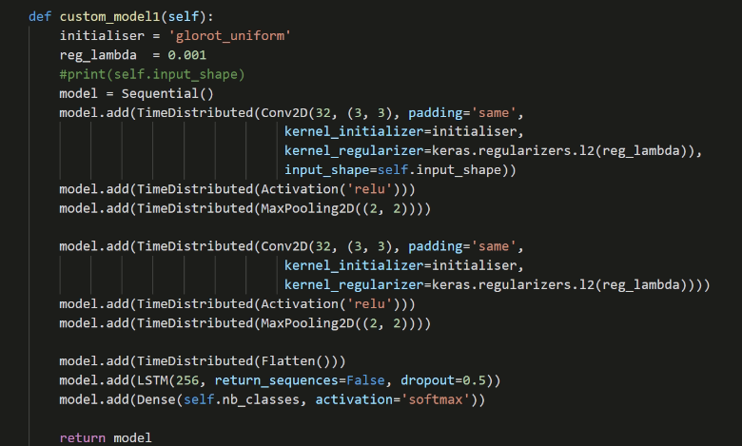With the help of UCF dataset, we managed to build the code that preprocess the videos (organize them and extract the frames from each video using ffmpeg tool), we also built an initial small CNN + LSTM model that we used in training.

Figure 2.2: The initial custom model for training

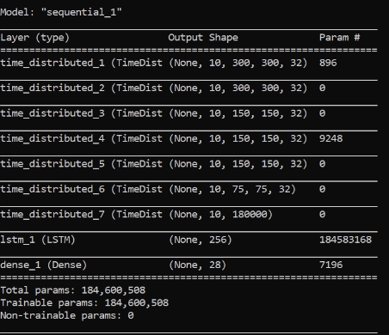To try this model we took a segment that belongs to one signer and started with it to see whether our concept is capable to learn the patterns or not, each video of the dataset has around 30 frames we decided to pick 10 frames from each video as a start also resized all frames to be (300 x 300) this makes our input shape = 10 x 300 x 300 x 3, our model performed naively well and had an accuracy of 100% at training and validation, when we tried this model on a video that was preprocessed and had its frames extracted we got a false prediction of the sign, we believe that 10 frames from each video was not a good choice so we are changed it to be near the minimum number of frames at the videos in the dataset which is 30 frames and it did perform really well.

Figure 2.4: The custom model architecture

The next step is to train the model with 4 signers’ videos, enhance and tune a model to get the best results.

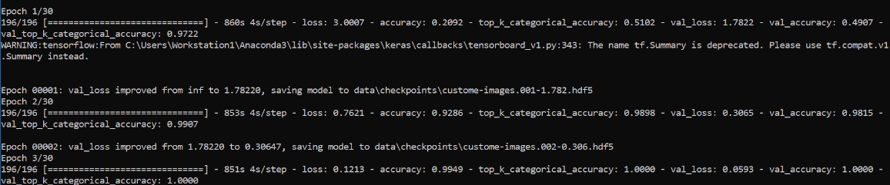

Figure 2.5: Snapshot from the training process

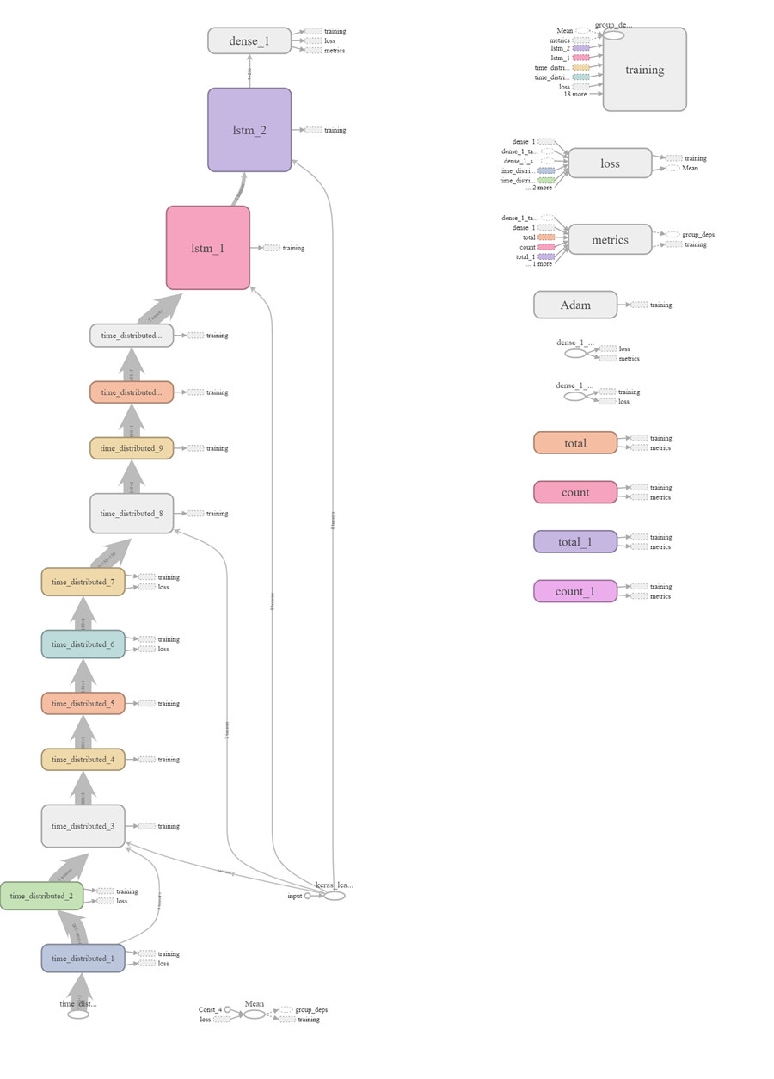We added multiple Conv2D layers to extract better and more features that the LSTM can learn from and added another LSTM that takes the sequence from its prior LSTM and produces a vector to the output Dense layer.

Figure 2.3: The modified custom model architecture graph

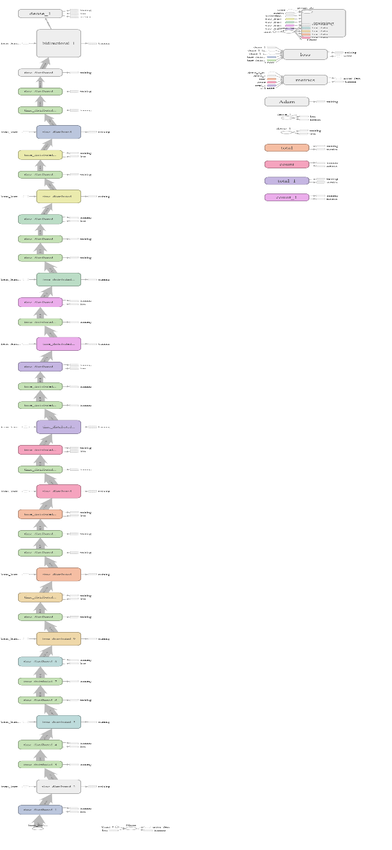The Previous Model Did not Perform significantly better that than the first one so we used a similar architecture introduced in an Action Recognition Paper called [Very Deep Convolutional Networks for Large-Scale Image Recognition](https://arxiv.org/abs/1409.1556)**,** and used a Bidirectional LSTM at the end as advised by the [Deep ASL Paper](https://arxiv.org/abs/1802.07584) and this is our Final Model Architecture.

Training this model took a very large time but was robust and has better results than the priors so we save its weights to use in the next step.

The final step in this model is to build a script that takes a video as frames and pass every sequence of frames to our model to be interpreted.

The following segment shows part of the training process.

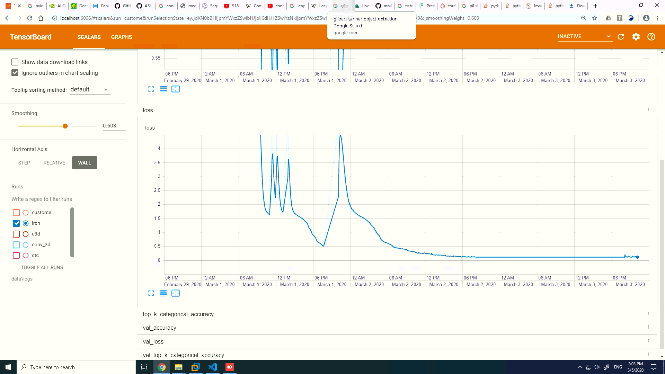 Figure 2.x: Training process of the enhanced model through days of fine tuning.

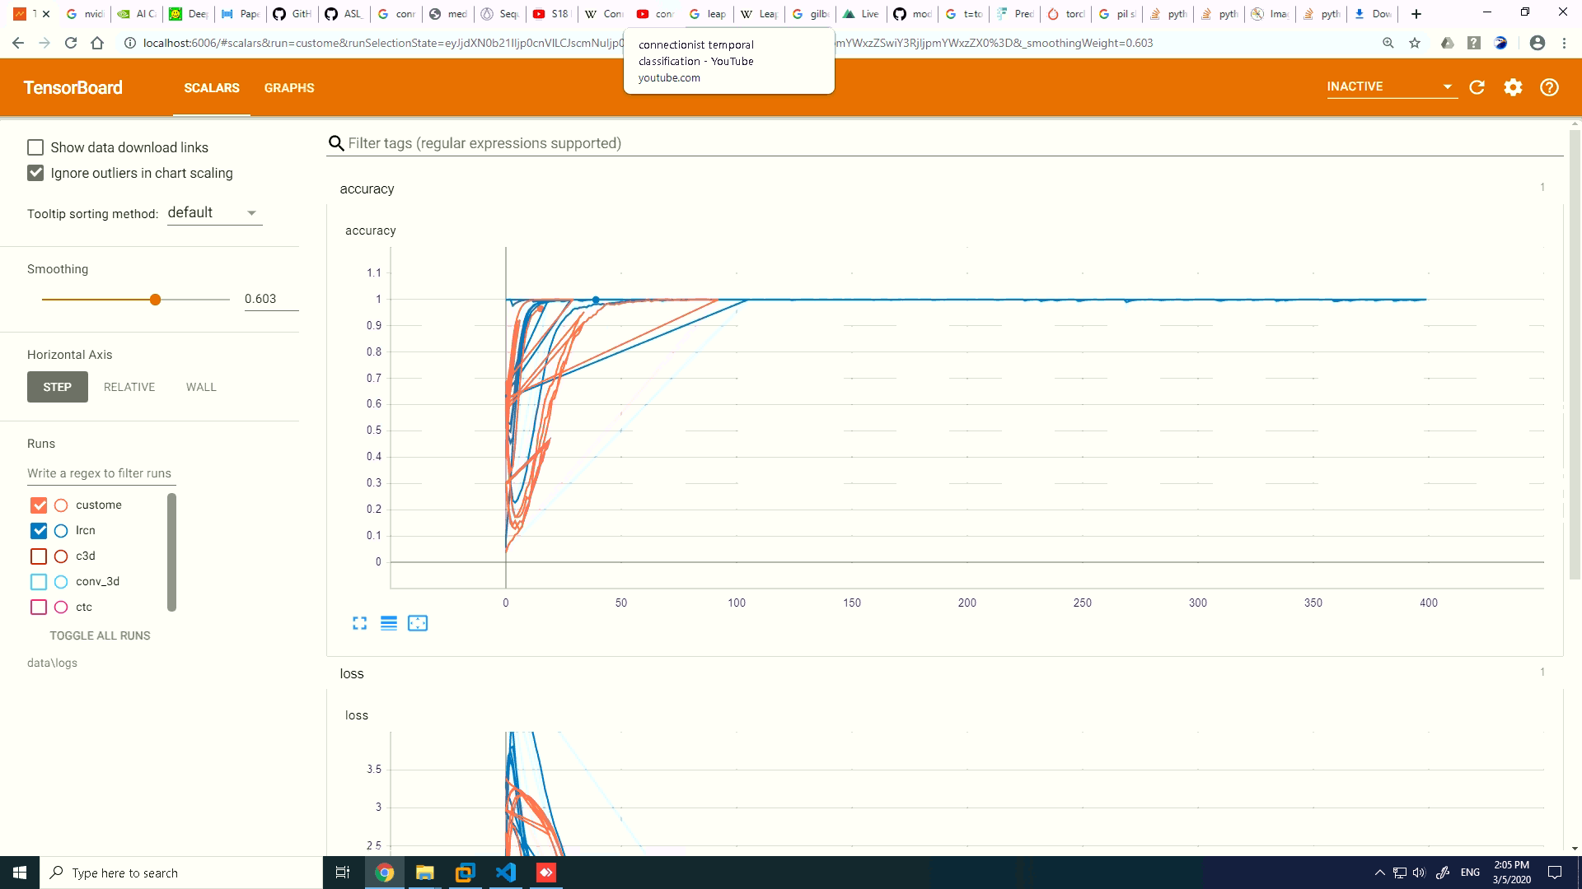

Figure 2.6: results of the different model we have tried

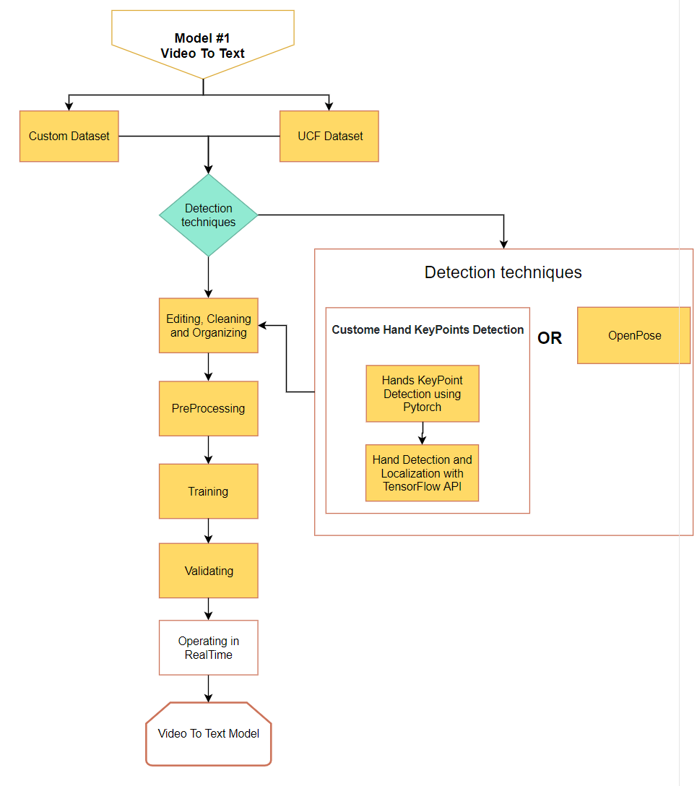

Figure 2.7: Model 1 graph

**Model #2**

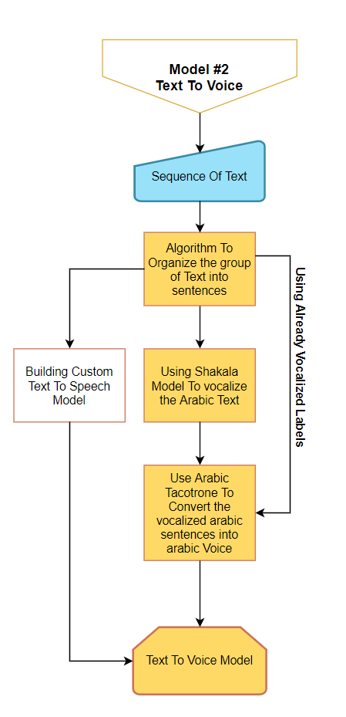The second model converts Arabic text to Arabic voice, we have multiple techniques to do so,

* first, we vocalize the text using a model called Shakkala then give this vocalized text to a model based on Google’s tacotrone to convert it to Arabic voice.

**Deployment**

Deploying a Deep learning model is not an easy task, especially in our case where we have multiple models running simultaneously that is despite the fact that these models needs to be running in real time as well as being portable e.g. (Phone).

Figure 2.8: Model 2 graph

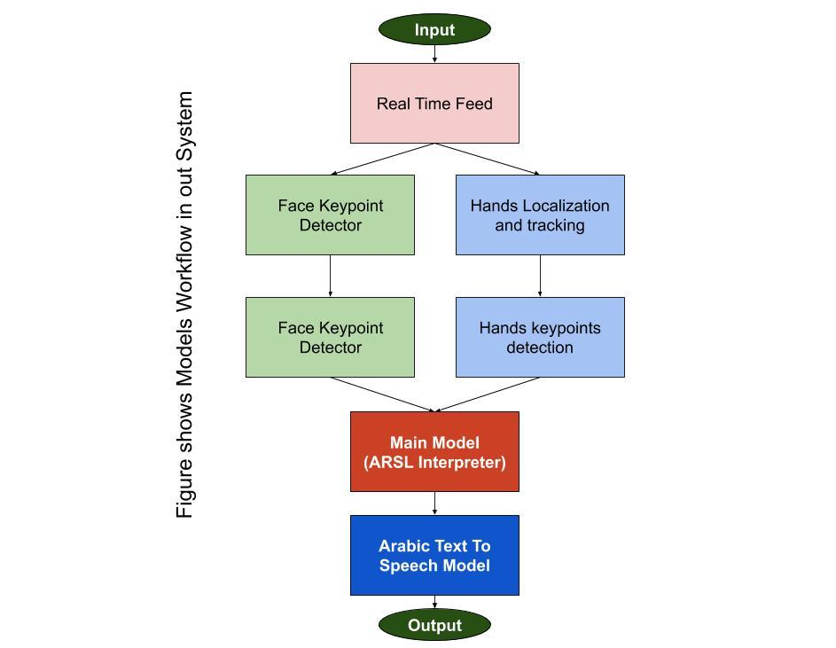

Figure 2.10: Models workflow graph

As shown above and mentioned earlier, our system has multiple models that needs to be handled efficiently.

**Available Deployment Approaches:**

**First:** We can save the models (freeze their weights) and use them on power computer with huge GPU power.

**Pros:**

This will make deployment a lot easier and save a lot of time as we do not need to worry about computation power needed to operate these models

**Cons:**

1. Lack of Portability
2. Inaccessibility to normal users
3. The device will not be feasible to normal users

**Second:** transform all these models to TensorFlow Lite models that has small size and can run on mobile Apps.

**Pros:**

1. Great portability advantage
2. Memory optimization
3. No need to connect to the internet to get the Service

**Cons:**

1. A lot of time needed to transform and edit these models
2. The performance will decrease due to transformation downgrading
3. Even if all the above steps completed successfully, we still do not know for sure if it will be fast enough on mobile phones
4. Not all phones would be able to run such application

**Third:** we buy a high computation server to deploy our model on, this way the model can be accessed by mobile applications or normal websites without being slow.

**Pros:**

1. Compatibility with every software that connects to internet
2. This way any lightweight app that runs on all mobile phone would be able to get the service, this way any user with a connection to internet would get the service.
3. This increases the feasibility and portability and that the core advantage

**Cons:**

1. Internet connection that handles streaming is not available everywhere like in our target case, Egypt.

After many researches and experiments we chose to go with the third deployment method, and the following steps are to be made:

Create a website using flask that can talk directly to the model, it sends a video feed to the model and receives the interpretations back.

Look up a server that is affordable to us in the meantime, to deploy our system on.

Last step is making an API that takes the video feed from the Flask website and gives us back the interpretations.

**Current Results:**

For our prototype, we built a simple web page using HTML and JavaScript. The web page receives a video then processes it extracting the frames, after that it calls our Prediction model to predict the corresponding word (label) for the given video and return it as a message through our page.